**Practical No -6**

**Problem stmt :** Write a Stored Procedure namely proc_Grade for the categorization of student. If marks scored by students in examination is <=1500 and marks>=990 then student will be placed in distinction category if marks scored are between 989 and900 category is first class, if marks 899 and 825 category is Higher Second Class Write a PL/SQL block for using procedure created with above requirement.

set SERVEROUTPUT ON

create or replace procedure grade_calc(stud_id IN number)

is

begin

declare

marks number(10);

--stud_id number (10):&amp;rollno;

begin

select totalmarks into marks from stud_marks where rollno=stud_id;

if marks<=1500 And marks>=990 then

insert into result values(stud_id,'Distinction');

dbms_output.put_line('student is passed with first class distinction');

elsif marks<=989 And marks>=900 then

insert into result values(stud_id,'First class');

dbms_output.put_line('student is passed with first class ');

elsif marks<=899 And marks>=825 then

insert into result values(stud_id,'Second class');

dbms_output.put_line('student is passed with second class');

elsif marks<=824 And marks>=400 then

insert into result values(stud_id,'pass');

dbms_output.put_line('pass');

else

dbms_output.put_line('student is failed ');

insert into result values(stud_id,'fail');

end if;

end ;

end;

exec grade_calc(23);

*stud_marks:*

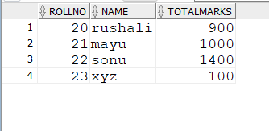

*Result:*

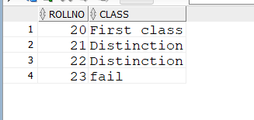

**Problem stmt :**

Consider following schema for Bank database. Account(Account_No, Cust_Name, Balance, NoOfYears) Earned_Interest(Account_No,Interest_Amt) Write a PL/SQL procedure for following requirement. Take as input Account_No and Interest Rate from User. Calculate the Interest_Amt as simple interest for the given Account_No and store it in Earned_Interest table. Display all the details of Earned_Interest Table.

create or replace procedure calc_interest(acc1 number,rate number)

is

begin

declare

bal number(10);

t_year number(20);

interest_amt number(20);

begin

select balance into bal from acc where accno=acc1;

select no_of_year into t_year from acc where accno=acc1;

interest_amt:=( bal*rate*t_year)/100;

insert into interest_amount values(acc1,interest_amt);

end;

end;

exec calc_interest(1002,7);

*Acc*

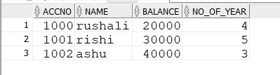

*interest_amount*

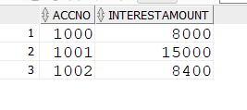

**Problem stmt :**

Write a stored function in PL/SQL for given requirement and use the same in PL/SQL block.

Account no. and branch name will be accepted from user. The same will be searched in table acct_details. If status of account is active then display appropriate message and also store the account details in active_acc_details table, otherwise display message on screen “account is inactive”.

create or replace function active_acc_details(acc number)

return varchar

is

begin

declare

st varchar(30);

begin

select status into st from account_details where accno=acc;

return st;

end;

end;

set SERVEROUTPUT ON;

declare

br varchar(20);

bal number(20);

st_x varchar(20);

acc1 number(20):=&accountno;

begin

select branch into br from account_details where accno=acc1;

select balance into bal from account_details where accno=acc1;

st_x:=active_acc_details(acc1);

if st_x='active' then

insert into active_account values(acc1,br,bal);

else

dbms_output.put_line('account is not active');

end if;

end;

*account_details*

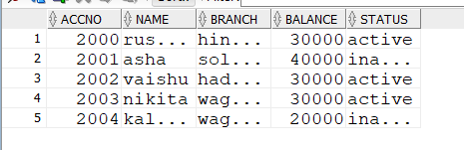

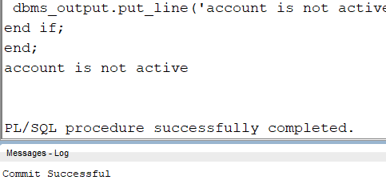

*active_account*

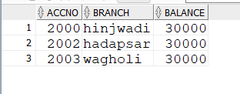

**Problem stmt :**

Consider following schema for Sales table Sales (Item_No int, Quantity int, Unit_Price number, Status varchar(20)) Status can be “Shipped” or “Delivered” or “Returned” Write a PLSQL function to calculate the total amount of Sales for Items with status “Shipped”. (total_amount = SUM(Quantity * Unit_Price) Display the Total Amount of sales.

CREATE OR REPLACE FUNCTION CalculateShippedSalesTotal RETURN NUMBER IS

total_amount NUMBER := 0;

BEGIN

SELECT SUM(Quantity * Unit_Price)

INTO total_amount

FROM Sales

WHERE Status = 'Shipped';

RETURN total_amount;

END;

DECLARE

total NUMBER;

BEGIN

total := CalculateShippedSalesTotal;

DBMS_OUTPUT.PUT_LINE('Total Shipped Sales Amount: ' || total);

END;

*Sales*

